EXPERIMENT NO: 1

Aim:

Create an Employee Table with the help of Data Mining Tool WEKA.

Description:

We need to create an Employee Table with training data set which includes attributes like name, id, salary, experience, gender, phone number.

Procedure:

Steps:

- Open Start → Programs → Accessories → Notepad
- Type the following training data set with the help of Notepad for Employee Table.

@relation employee @attribute name {x,y,z,a,b} @attribute id numeric
@attribute salary {low,medium,high} @attribute exp numeric
@attribute gender {male,female} @attribute phone numeric

@data x,101,low,2,male,250311 y,102,high,3,female,251665 z,103,medium,1,male,240238 a,104,low,5,female,200200 b,105,high,2,male,240240

- After that the file is saved with .arff file format.
- Minimize the arff file and then open Start → Programs → weka-3-4.
- Click on weka-3-4, then Weka dialog box is displayed on the screen.
- In that dialog box there are four modes, click on explorer.
- Explorer shows many options. In that click on ‘open file’ and select the arff file
- Click on edit button which shows employee table on weka.

Training Data Set → Weather Table
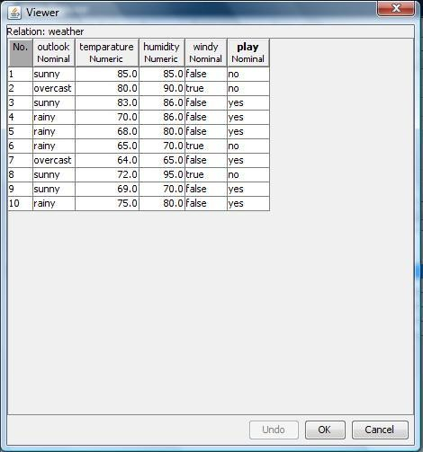

Result:

This program has been successfully executed.
EXPERIMENT NO:2

Aim:

Create a Weather Table with the help of Data Mining Tool WEKA.

Description:

We need to create a Weather table with training data set which includes attributes like outlook, temperature, humidity, windy, play.

Procedure:

Steps:

- Open Start → Programs → Accessories → Notepad
- Type the following training data set with the help of Notepad for Weather Table.

@relation weather
@attribute outlook {sunny,rainy,overcast} @attribute temparature numeric @attribute humidity numeric
@attribute windy {true,false} @attribute play {yes,no}

@data sunny,85.0,85.0,false,no overcast,80.0,90.0,true,no sunny,83.0,86.0,false,yes rainy,70.0,86.0,false,yes rainy,68.0,80.0,false,yes rainy,65.0,70.0,true,no overcast,64.0,65.0,false,yes sunny,72.0,95.0,true,no sunny,69.0,70.0,false,yes rainy,75.0,80.0,false,yes

- After that the file is saved with .arff file format.
- Minimize the arff file and then open Start → Programs → weka-3-4.
- Click on weka-3-4, then Weka dialog box is displayed on the screen.
- In that dialog box there are four modes, click on explorer.
- Explorer shows many options. In that click on ‘open file’ and select the arff file
- Click on edit button which shows weather table on weka.

Training Data Set → Weather Table

Result:

This program has been successfully executed.
EXPERIMENT NO:3

Aim:

Apply Pre-Processing techniques to the training data set of Weather Table

Description:

Real world databases are highly influenced to noise, missing and inconsistency due to their queue size so the data can be pre-processed to improve the quality of data and missing results and it also improves the efficiency.
There are 3 pre-processing techniques they are:

  - Add
  - Remove
  - Normalization

Creation of Weather Table:

Procedure:

- Open Start → Programs → Accessories → Notepad
- Type the following training data set with the help of Notepad for Weather Table.

@relation weather
@attribute outlook {sunny,rainy,overcast} @attribute temparature numeric @attribute humidity numeric
@attribute windy {true,false} @attribute play {yes,no}

@data sunny,85.0,85.0,false,no overcast,80.0,90.0,true,no sunny,83.0,86.0,false,yes rainy,70.0,86.0,false,yes rainy,68.0,80.0,false,yes rainy,65.0,70.0,true,no overcast,64.0,65.0,false,yes sunny,72.0,95.0,true,no sunny,69.0,70.0,false,yes rainy,75.0,80.0,false,yes
- After that the file is saved with .arff file format.
- Minimize the arff file and then open Start → Programs → weka-3-4.
- Click on weka-3-4, then Weka dialog box is displayed on the screen.
- In that dialog box there are four modes, click on explorer.
- Explorer shows many options. In that click on ‘open file’ and select the arff file
- Click on edit button which shows weather table on weka.

Add → Pre-Processing Technique:

Procedure:

  - Start → Programs → Weka-3-4 → Weka-3-4
  - Click on explorer.
  - Click on open file.
  - Select Weather.arff file and click on open.
  - Click on Choose button and select the Filters option.
  - In Filters, we have Supervised and Unsupervised data.
  - Click on Unsupervised data.
  - Select the attribute Add.
  - A new window is opened.
  - In that we enter attribute index, type, data format, nominal label values for Climate.
  - Click on OK.
  - Press the Apply button, then a new attribute is added to the Weather Table.
  - Save the file.
  - Click on the Edit button, it shows a new Weather Table on Weka.

Weather Table after adding new attribute CLIMATE:
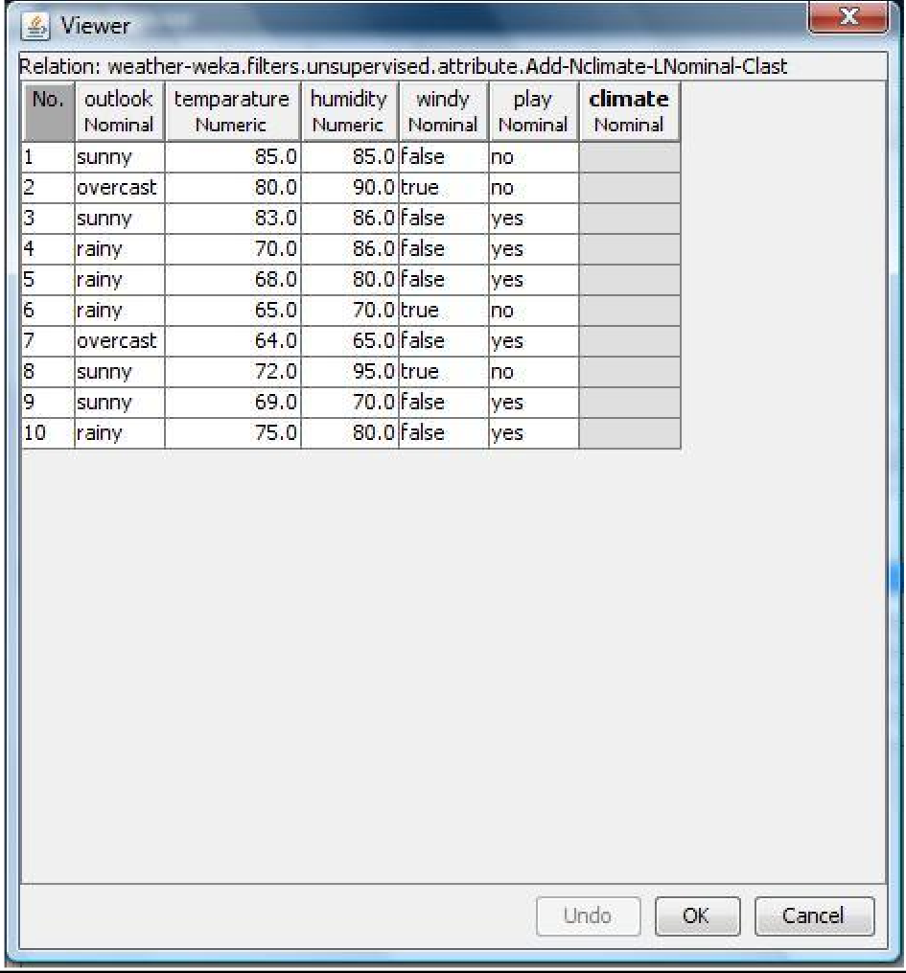

Remove → Pre-Processing Technique:

Procedure:

- Start → Programs → Weka-3-4 → Weka-3-4
- Click on explorer.
- Click on open file.
- Select Weather.arff file and click on open.
- Click on Choose button and select the Filters option.
- In Filters, we have Supervised and Unsupervised data.
- Click on Unsupervised data.
- Select the attribute Remove.
- Select the attributes windy, play to Remove.
- Click Remove button and then Save.
- Click on the Edit button, it shows a new Weather Table on Weka.

Weather Table after removing attributes WINDY, PLAY:

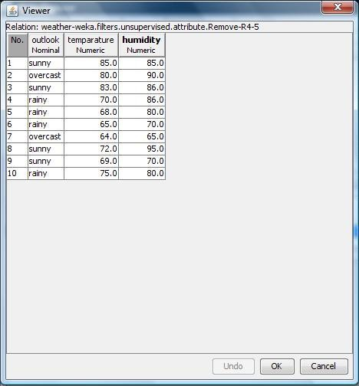

Normalize → Pre-Processing Technique:

Procedure:

- Start → Programs → Weka-3-4 → Weka-3-4
- Click on explorer.
- Click on open file.
- Select Weather.arff file and click on open.
- Click on Choose button and select the Filters option.
- In Filters, we have Supervised and Unsupervised data.
- Click on Unsupervised data.
- Select the attribute Normalize.
- Select the attributes temparature, humidity to Normalize.
- Click on Apply button and then Save.
- Click on the Edit button, it shows a new Weather Table with normalized values on Weka.

Weather Table after Normalizing TEMPARATURE, HUMIDITY:
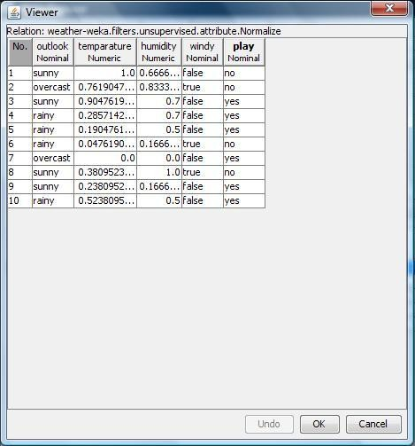

Result:

This program has been successfully executed.
EXPERIMENT NO:4

Aim:

Apply Pre-Processing techniques to the training data set of Employee Table

Description:

Real world databases are highly influenced to noise, missing and inconsistency due to their queue size so the data can be pre-processed to improve the quality of data and missing results and it also improves the efficiency.
There are 3 pre-processing techniques they are:

- Add
- Remove
- Normalization

Creation of Employee Table:

Procedure:

- Open Start → Programs → Accessories → Notepad
- Type the following training data set with the help of Notepad for Employee Table.

@relation employee @attribute name {x,y,z,a,b} @attribute id numeric
@attribute salary {low,medium,high} @attribute exp numeric
@attribute gender {male,female} @attribute phone numeric

@data x,101,low,2,male,250311 y,102,high,3,female,251665 z,103,medium,1,male,240238 a,104,low,5,female,200200 b,105,high,2,male,240240

- After that the file is saved with .arff file format.
- Minimize the arff file and then open Start → Programs → weka-3-4.
- Click on weka-3-4, then Weka dialog box is displayed on the screen.
- In that dialog box there are four modes, click on explorer.
- Explorer shows many options. In that click on ‘open file’ and select the arff file
- Click on edit button which shows employee table on weka.

Training Data Set → Employee Table
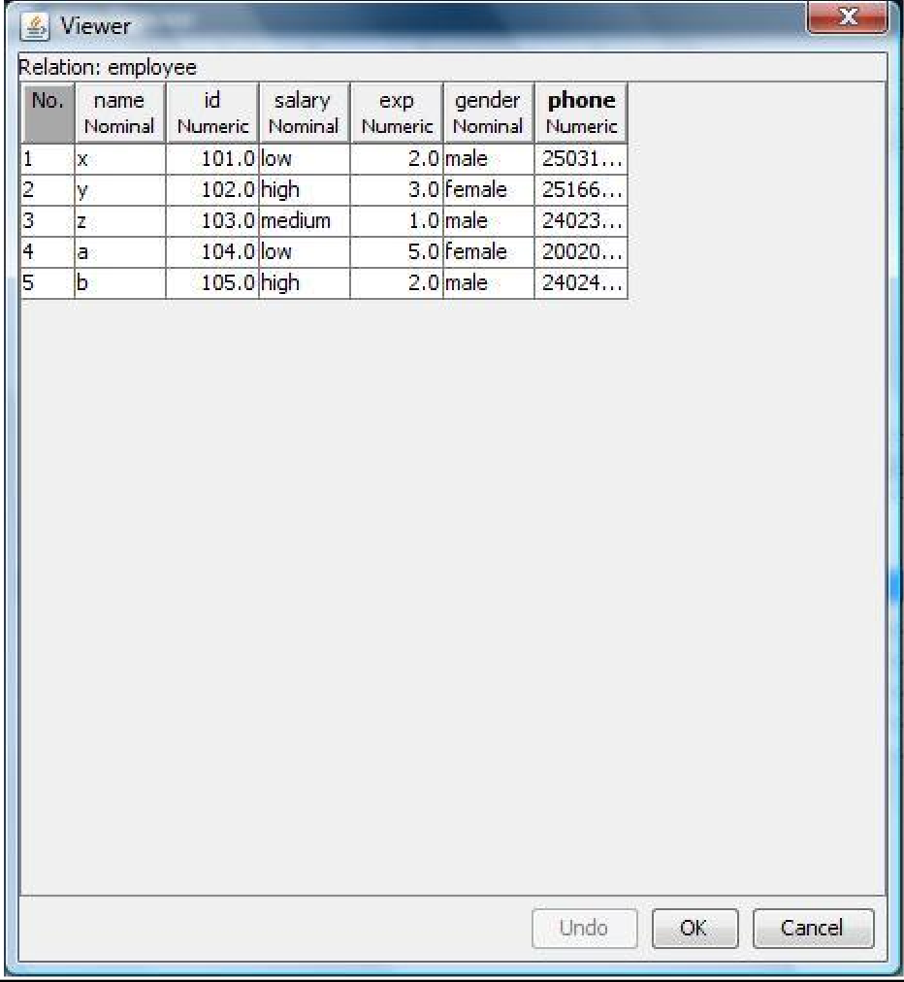
Add → Pre-Processing Technique:

Procedure:

  - Start → Programs → Weka-3-4 → Weka-3-4
  - Click on explorer.
  - Click on open file.
  - Select Employee.arff file and click on open.
  - Click on Choose button and select the Filters option.
  - In Filters, we have Supervised and Unsupervised data.
  - Click on Unsupervised data.
  - Select the attribute Add.
  - A new window is opened.
  - In that we enter attribute index, type, data format, nominal label values for Address.
  - Click on OK.
  - Press the Apply button, then a new attribute is added to the Employee Table.
  - Save the file.
  - Click on the Edit button, it shows a new Employee Table on Weka.

Employee Table after adding new attribute ADDRESS:
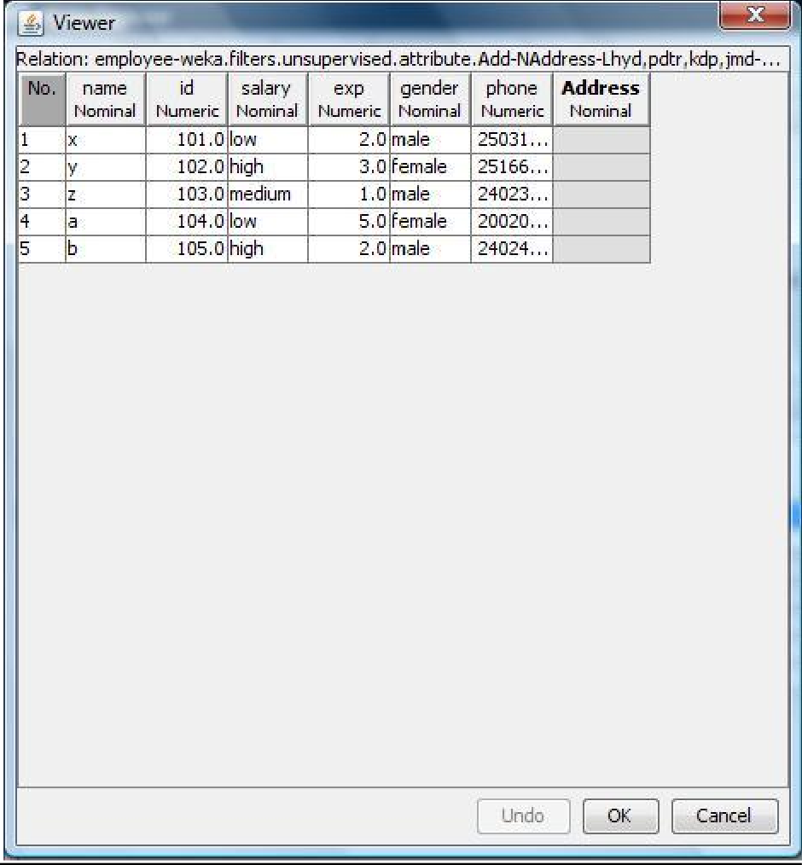
Remove → Pre-Processing Technique:

Procedure:

- Start → Programs → Weka-3-4 → Weka-3-4
- Click on explorer.
- Click on open file.
- Select Employee.arff file and click on open.
- Click on Choose button and select the Filters option.
- In Filters, we have Supervised and Unsupervised data.
- Click on Unsupervised data.
- Select the attribute Remove.
- Select the attributes salary, gender to Remove.
- Click Remove button and then Save.
- Click on the Edit button, it shows a new Employee Table on Weka.

Employee Table after removing attributes SALARY, GENDER:
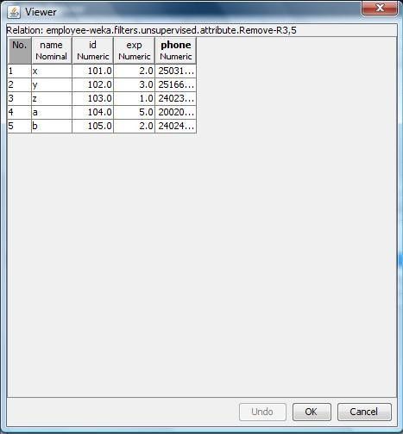

Normalize → Pre-Processing Technique:

Procedure:

- Start → Programs → Weka-3-4 → Weka-3-4
- Click on explorer.
- Click on open file.
- Select Employee.arff file and click on open.
- Click on Choose button and select the Filters option.
- In Filters, we have Supervised and Unsupervised data.
- Click on Unsupervised data.
- Select the attribute Normalize.
- Select the attributes id, experience, phone to Normalize.
- Click on Apply button and then Save.
- Click on the Edit button, it shows a new Employee Table with normalized values on Weka.

Employee Table after Normalizing ID, EXP, PHONE:
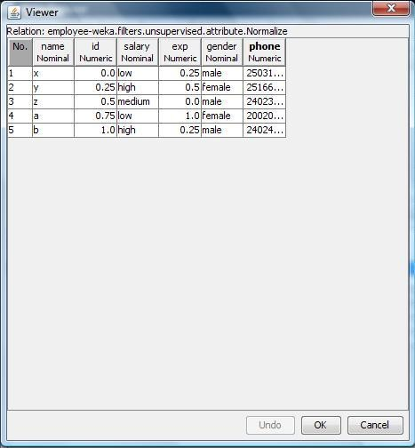

Result:

This program has been successfully executed.
EXPERIMENT NO:5

Aim:

Normalize Weather Table data using Knowledge Flow.

Description:

The knowledge flow provides an alternative way to the explorer as a graphical front end to WEKA’s algorithm. Knowledge flow is a working progress. So, some of the functionality from explorer is not yet available. So, on the other hand there are the things that can be done in knowledge flow, but not in explorer. Knowledge flow presents a dataflow interface to WEKA. The user can select WEKA components from a toolbar placed them on a layout campus and connect them together in order to form a knowledge flow for processing and analyzing the data.

Creation of Weather Table:

Procedure:

- Open Start → Programs → Accessories → Notepad
- Type the following training data set with the help of Notepad for Weather Table.

@relation weather
@attribute outlook {sunny,rainy,overcast} @attribute temparature numeric @attribute humidity numeric
@attribute windy {true,false} @attribute play {yes,no}

@data sunny,85.0,85.0,false,no overcast,80.0,90.0,true,no sunny,83.0,86.0,false,yes rainy,70.0,86.0,false,yes rainy,68.0,80.0,false,yes rainy,65.0,70.0,true,no overcast,64.0,65.0,false,yes sunny,72.0,95.0,true,no sunny,69.0,70.0,false,yes rainy,75.0,80.0,false,yes
- After that the file is saved with .arff file format.
- Minimize the arff file and then open Start → Programs → weka-3-4.
- Click on weka-3-4, then Weka dialog box is displayed on the screen.
- In that dialog box there are four modes, click on explorer.
- Explorer shows many options. In that click on ‘open file’ and select the arff file
- Click on edit button which shows Weather table on weka.

Output:

Training Data Set → Weather Table

Procedure for Knowledge Flow:

- Open Start → Programs → Weka-3-4 → Weka-3-4
- Open the Knowledge Flow.
- Select the Data Source component and add Arff Loader into the knowledge layout canvas.
- Select the Filters component and add Attribute Selection and Normalize into the knowledge layout canvas.
- Select the Data Sinks component and add Arff Saver into the knowledge layout canvas.
- Right click on Arff Loader and select Configure option then the new window will be opened and select
Weather.arff
- Right click on Arff Loader and select Dataset option then establish a link between Arff Loader and Attribute Selection.
- Right click on Attribute Selection and select Dataset option then establish a link between Attribute Selection and Normalize.
- Right click on Attribute Selection and select Configure option and choose the best attribute for Weather data.
- Right click on Normalize and select Dataset option then establish a link between Normalize and Arff Saver.
- Right click on Arff Saver and select Configure option then new window will be opened and set the path, enter .arff in look in dialog box to save normalize data.
- Right click on Arff Loader and click on Start Loading option then everything will be executed one by one.
- Check whether output is created or not by selecting the preferred path.
- Rename the data name as a.arff
- Double click on a.arff then automatically the output will be opened in MS-Excel.
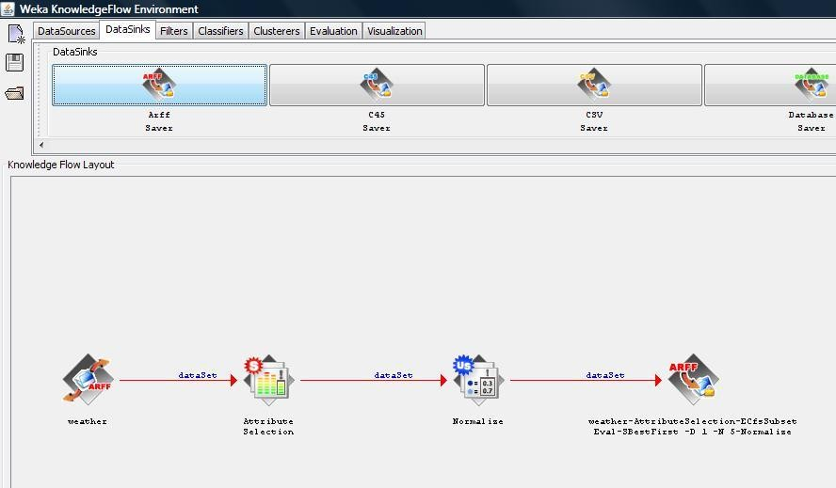

Result:

This program has been successfully executed.
EXPERIMENT NO:6

Aim:

Normalize Employee Table data using Knowledge Flow.

Description:

The knowledge flow provides an alternative way to the explorer as a graphical front end to WEKA’s algorithm. Knowledge flow is a working progress. So, some of the functionality from explorer is not yet available. So, on the other hand there are the things that can be done in knowledge flow, but not in explorer. Knowledge flow presents a dataflow interface to WEKA. The user can select WEKA components from a toolbar placed them on a layout campus and connect them together in order to form a knowledge flow for processing and analyzing the data.

Creation of Employee Table:

Procedure:

- Open Start → Programs → Accessories → Notepad
- Type the following training data set with the help of Notepad for Employee Table. @relation employee
@attribute eid numeric
@attribute ename {raj,ramu,anil,sunil,rajiv,sunitha,kavitha,suresh,ravi,ramana,ram,kavya,navya} @attribute salary numeric
@attribute exp numeric
@attribute address {pdtr,kdp,nlr,gtr} @data
101,raj,10000,4,pdtr 102,ramu,15000,5,pdtr 103,anil,12000,3,kdp 104,sunil,13000,3,kdp 105,rajiv,16000,6,kdp 106,sunitha,15000,5,nlr 107,kavitha,12000,3,nlr 108,suresh,11000,5,gtr 109,ravi,12000,3,gtr 110,ramana,11000,5,gtr 111,ram,12000,3,kdp 112,kavya,13000,4,kdp 113,navya,14000,5,kdp
- After that the file is saved with .arff file format.
- Minimize the arff file and then open Start → Programs → weka-3-4.
- Click on weka-3-4, then Weka dialog box is displayed on the screen.
- In that dialog box there are four modes, click on explorer.
- Explorer shows many options. In that click on ‘open file’ and select the arff file
- Click on edit button which shows employee table on weka.

Output:

Training Data Set → Employee Table
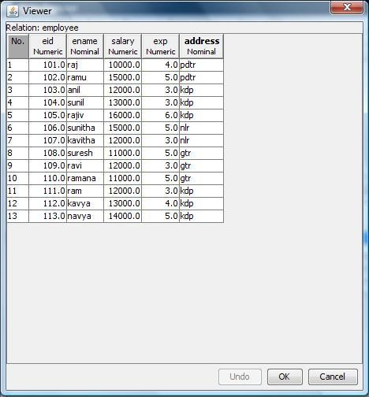

Procedure for Knowledge Flow:

- Open Start → Programs → Weka-3-4 → Weka-3-4
- Open the Knowledge Flow.
- Select the Data Source component and add Arff Loader into the knowledge layout canvas.
- Select the Filters component and add Attribute Selection and Normalize into the knowledge layout canvas.
- Select the Data Sinks component and add Arff Saver into the knowledge layout canvas.
- Right click on Arff Loader and select Configure option then the new window will be opened and select
Employee.arff
- Right click on Arff Loader and select Dataset option then establish a link between Arff Loader and Attribute Selection.
- Right click on Attribute Selection and select Dataset option then establish a link between Attribute Selection and Normalize.
- Right click on Attribute Selection and select Configure option and choose the best attribute for Employee data.
- Right click on Normalize and select Dataset option then establish a link between Normalize and Arff Saver.
- Right click on Arff Saver and select Configure option then new window will be opened and set the path, enter .arff in look in dialog box to save normalize data.
- Right click on Arff Loader and click on Start Loading option then everything will be executed one by one.
- Check whether output is created or not by selecting the preferred path.
- Rename the data name as a.arff
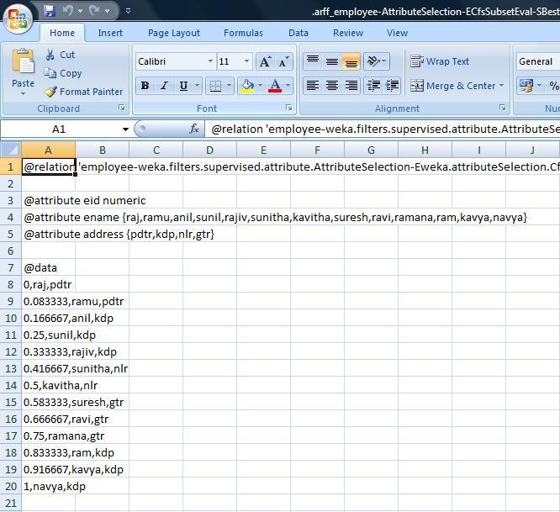
- Double click on a.arff then automatically the output will be opened in MS-Excel.

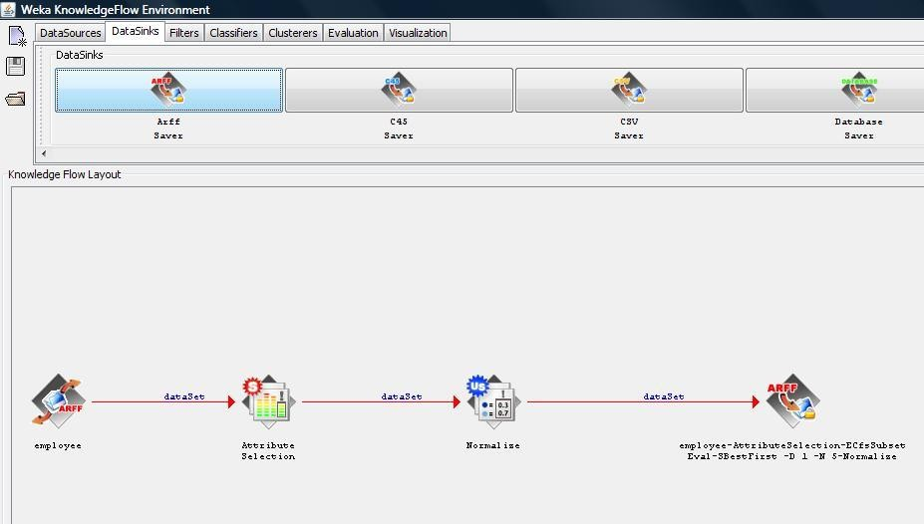
Result:

This program has been successfully executed.
EXPERIMENT NO:7

Aim: Finding Association Rules for Buying data.

Description:

In data mining, association rule learning is a popular and well researched method for discovering interesting relations between variables in large databases. It can be described as analyzing and presenting strong rules discovered in databases using different measures of interestingness. In market basket analysis association rules are used and they are also employed in many application areas including Web usage mining, intrusion detection and bioinformatics.

Creation of Buying Table:

Procedure:

- Open Start → Programs → Accessories → Notepad
- Type the following training data set with the help of Notepad for Buying Table. @relation buying
@attribute age {L20,20-40,G40} @attribute income {high,medium,low} @attribute stud {yes,no}
@attribute creditrate {fair,excellent} @attribute buyscomp {yes,no} @data
L20,high,no,fair,yes 20-40,low,yes,fair,yes
G40,medium,yes,fair,yes L20,low,no,fair,no G40,high,no,excellent,yes L20,low,yes,fair,yes
20-40,high,yes,excellent,no G40,low,no,fair,yes L20,high,yes,excellent,yes G40,high,no,fair,yes L20,low,yes,excellent,no G40,high,yes,excellent,no
20-40,medium,yes,excellent,yes L20,medium,yes,fair,yes G40,high,yes,excellent,yes

- After that the file is saved with .arff file format.
- Minimize the arff file and then open Start → Programs → weka-3-4.
- Click on weka-3-4, then Weka dialog box is displayed on the screen.
- In that dialog box there are four modes, click on explorer.
- Explorer shows many options. In that click on ‘open file’ and select the arff file
- Click on edit button which shows buying table on weka.

Output:

Training Data Set → Buying Table
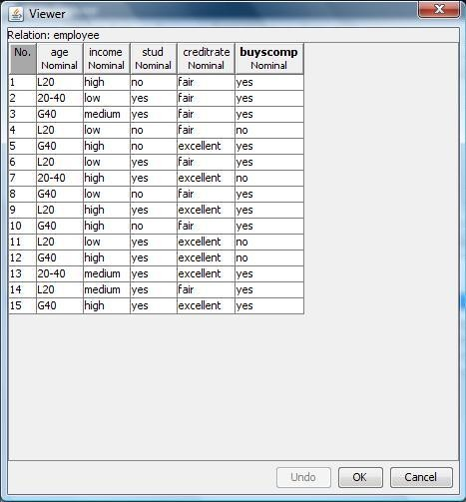

Procedure for Association Rules:

- Open Start → Programs → Weka-3-4 → Weka-3-4
- Open explorer.
- Click on open file and select buying.arff
- Select Associate option on the top of the Menu bar.
- Select Choose button and then click on Apriori Algorithm.
- Click on Start button and output will be displayed on the right side of the window.
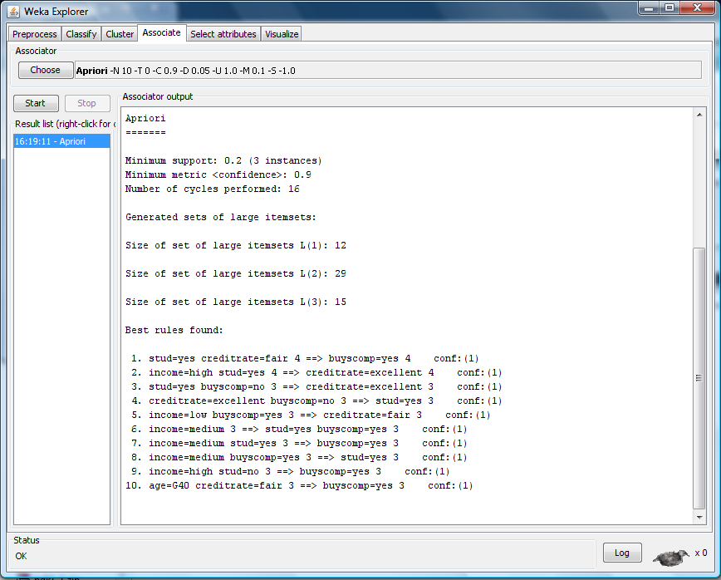

Result:

This program has been successfully executed.
EXPERIMENT NO:8

Aim: Finding Association Rules for Banking data.

Description:

In data mining, association rule learning is a popular and well researched method for discovering interesting relations between variables in large databases. It can be described as analyzing and presenting strong rules discovered in databases using different measures of interestingness. In market basket analysis association rules are used and they are also employed in many application areas including Web usage mining, intrusion detection and bioinformatics.

Creation of Banking Table:

Procedure:

- Open Start → Programs → Accessories → Notepad
- Type the following training data set with the help of Notepad for Banking Table. @relation bank
@attribute cust {male,female} @attribute accno
{0101,0102,0103,0104,0105,0106,0107,0108,0109,0110,0111,0112,0113,0114,0115}
@attribute bankname {sbi,hdfc,sbh,ab,rbi} @attribute location {hyd,jmd,antp,pdtr,kdp} @attribute deposit {yes,no}
@data male,0101,sbi,hyd,yes female,0102,hdfc,jmd,no male,0103,sbh,antp,yes male,0104,ab,pdtr,yes female,0105,sbi,jmd,no male,0106,ab,hyd,yes female,0107,rbi,jmd,yes female,0108,hdfc,kdp,no male,0109,sbh,kdp,yes male,0110,ab,jmd,no female,0111,rbi,kdp,yes male,0112,sbi,jmd,yes female,0113,rbi,antp,no male,0114,hdfc,pdtr,yes female,0115,sbh,pdtr,no
- After that the file is saved with .arff file format.
- Minimize the arff file and then open Start → Programs → weka-3-4.
- Click on weka-3-4, then Weka dialog box is displayed on the screen.
- In that dialog box there are four modes, click on explorer.
- Explorer shows many options. In that click on ‘open file’ and select the arff file
- Click on edit button which shows banking table on weka.

Training Data Set → Banking Table
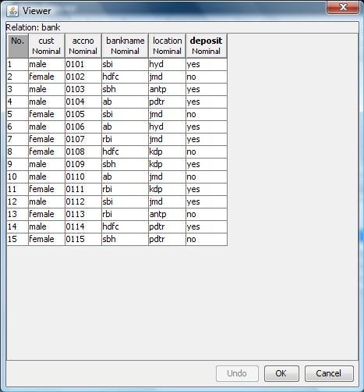

Procedure for Association Rules:

- Open Start → Programs → Weka-3-4 → Weka-3-4
- Open explorer.
- Click on open file and select bank.arff
- Select Associate option on the top of the Menu bar.
- Select Choose button and then click on Apriori Algorithm.
- Click on Start button and output will be displayed on the right side of the window.

Output:

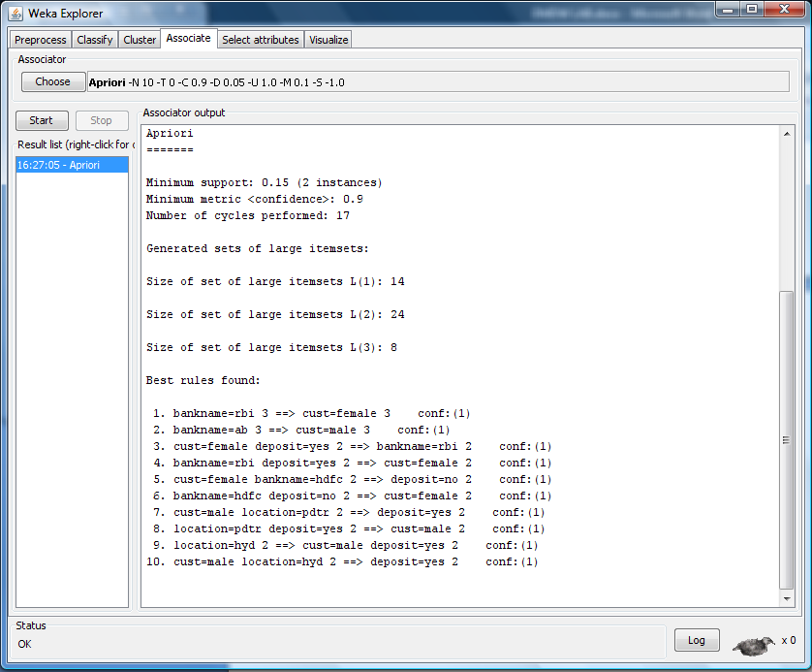

Result:

This program has been successfully executed.
EXPERIMENT NO:9

Aim: Finding Association Rules for Employee data.

Description:

In data mining, association rule learning is a popular and well researched method for discovering interesting relations between variables in large databases. It can be described as analyzing and presenting strong rules discovered in databases using different measures of interestingness. In market basket analysis association rules are used and they are also employed in many application areas including Web usage mining, intrusion detection and bioinformatics.

Creation of Banking Table:

Procedure:

  - Open Start → Programs → Accessories → Notepad
  - Type the following training data set with the help of Notepad for Employee Table. @relation employee-1
@attribute age {youth, middle, senior} @attribute income {high, medium, low} @attribute class {A, B, C}

@data
youth, high, A youth,medium,B youth, low, C middle, low, C middle, medium, C middle, high, A senior, low, C senior, medium, B senior, high, B middle, high, B

  - After that the file is saved with .arff file format.
  - Minimize the arff file and then open Start → Programs → weka-3-4.
  - Click on weka-3-4, then Weka dialog box is displayed on the screen.
  - In that dialog box there are four modes, click on explorer.
  - Explorer shows many options. In that click on ‘open file’ and select the arff file
  - Click on edit button which shows employee table on weka.

Training Data Set → Employee Table
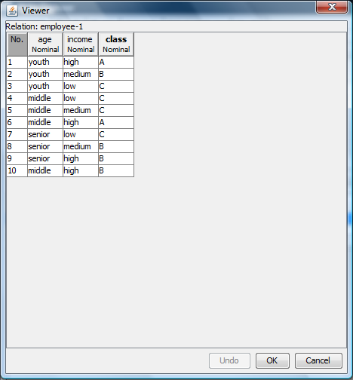
Procedure for Association Rules:

- Open Start → Programs → Weka-3-4 → Weka-3-4
- Open explorer.
- Click on open file and select employee-1.arff
- Select Associate option on the top of the Menu bar.
- Select Choose button and then click on Apriori Algorithm.
- Click on Start button and output will be displayed on the right side of the window.

Output:

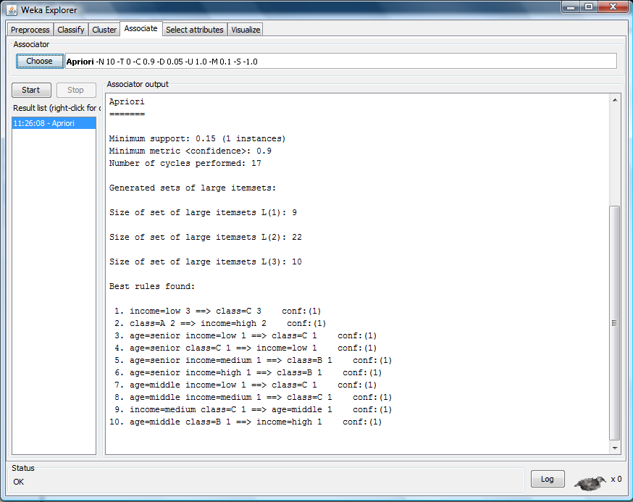

Result:

This program has been successfully executed.
EXPERIMENT NO:10

Aim:

To Construct Decision Tree for Weather data and classify it.

Description:

Classification & Prediction:

Classification is the process for finding a model that describes the data values and concepts for the purpose of Prediction.

Decision Tree:

A decision Tree is a classification scheme to generate a tree consisting of root node, internal nodes and external nodes.
Root nodes representing the attributes. Internal nodes are also the attributes. External nodes are the classes and each branch represents the values of the attributes
Decision Tree also contains set of rules for a given data set; there are two subsets in Decision Tree. One is a Training data set and second one is a Testing data set. Training data set is previously classified data. Testing data set is newly generated data.

Creation of Weather Table:

Procedure:

  - Open Start → Programs → Accessories → Notepad
  - Type the following training data set with the help of Notepad for Weather Table. @relation weather
@attribute outlook {sunny, rainy, overcast} @attribute temperature numeric
@attribute humidity numeric @attribute windy {TRUE, FALSE} @attribute play {yes, no}

@data sunny,85,85,FALSE,no sunny,80,90,TRUE,no overcast,83,86,FALSE,yes rainy,70,96,FALSE,yes rainy,68,80,FALSE,yes rainy,65,70,TRUE,no overcast,64,65,TRUE,yes sunny,72,95,FALSE,no sunny,69,70,FALSE,yes rainy,75,80,FALSE,yes sunny,75,70,TRUE,yes overcast,72,90,TRUE,yes overcast,81,75,FALSE,yes rainy,71,91,TRUE,no

  - After that the file is saved with .arff file format.
  - Minimize the arff file and then open Start → Programs → weka-3-4.
  - Click on weka-3-4, then Weka dialog box is displayed on the screen.
  - In that dialog box there are four modes, click on explorer.
  - Explorer shows many options. In that click on ‘open file’ and select the arff file
  - Click on edit button which shows weather table on weka.

Training Data Set → Weather Table
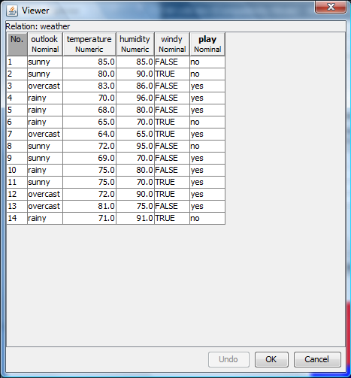
Procedure for Decision Trees:

- Open Start → Programs → Weka-3-4 → Weka-3-4
- Open explorer.
- Click on open file and select weather.arff
- Select Classifier option on the top of the Menu bar.
- Select Choose button and click on Tree option.
- Click on J48.
- Click on Start button and output will be displayed on the right side of the window.
- Select the result list and right click on result list and select Visualize Tree option.
- Then Decision Tree will be displayed on new window.

Output:
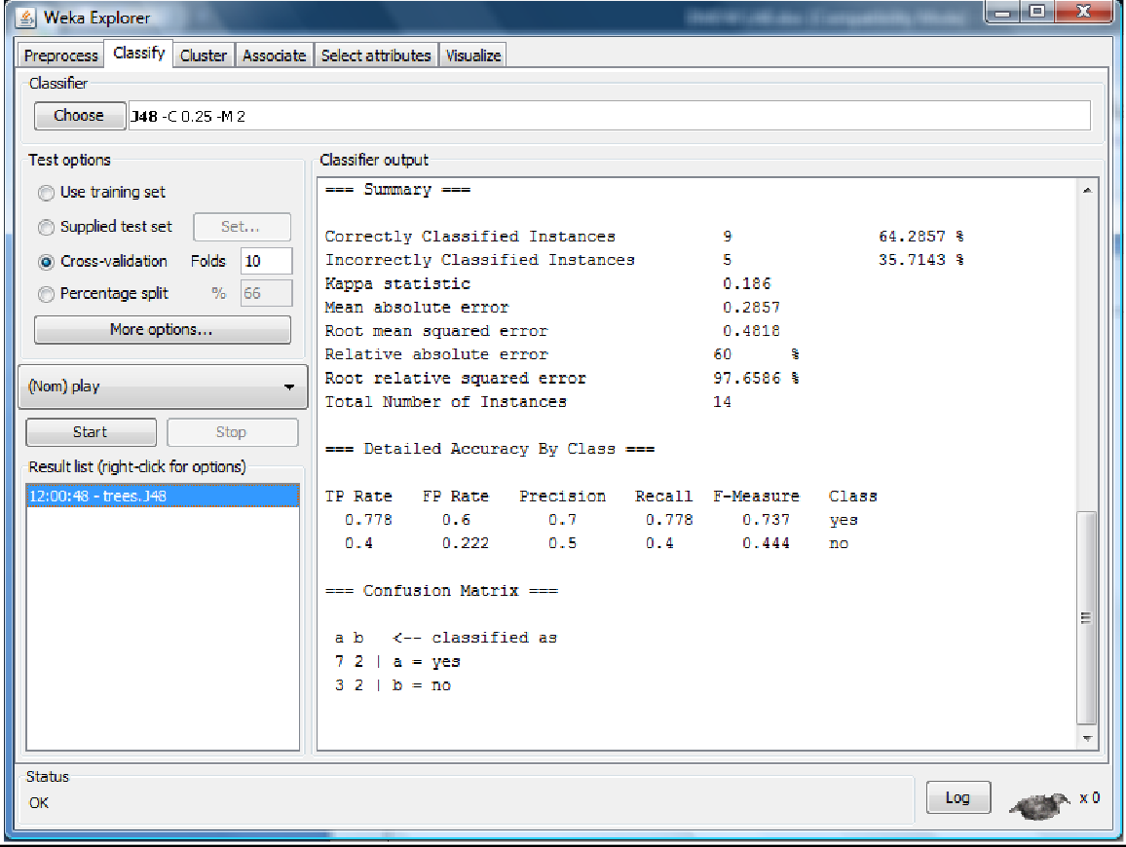
Decision Tree:
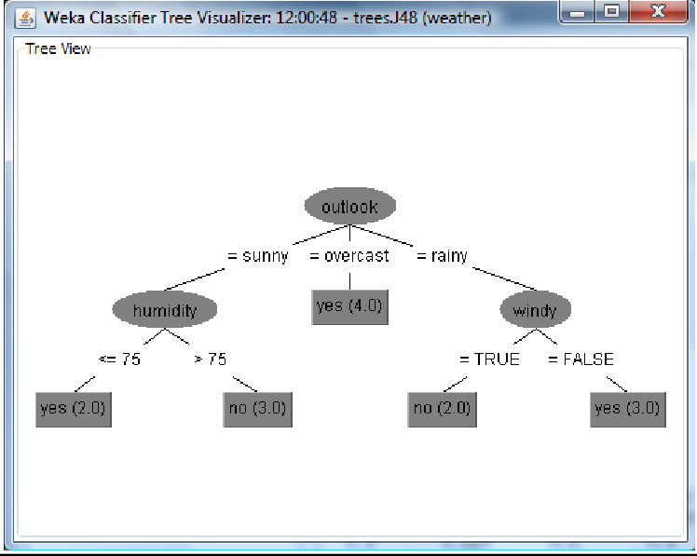

Result: This program has been successfully executed.

